**Request for quotation (RfQ) for the supply, installation and maintenance of a people / vehicle counting system and CCTV at Golden Bay.**

**Issued by** **the Malta Regional Development and Dialogue Foundation (MRDDf)**

[**www.mrddf.org**](http://www.mrddf.org)



[**https://tourismo.interreg-euro-med.eu/**](https://tourismo.interreg-euro-med.eu/)

**This project is being financed through INTERREG funds, in connection with the project “TOURISM INNOVATIVE AND SUSTAINABLE MANAGEMENT OF FLOWS (TOURISMO)”.  
Euro-MED0200900, INTERREG EURO-MEd Programme.**

**Date Issued: 08th July 2024**

**Closing Date: 26th July 2024**

|  |  |  |
| --- | --- | --- |
|  | **INTERREG Euro-MED Programme 2021-2027**  Project part financed by the European Union  European Regional Development Fund (ERDF)  Co-financing rate: 80% EU Funds; 20% National Funds |  |

**Table of Contents**

Section 1: Specifications 3

1.0 General Background 3

2.0 Performance Objectives 4

3.0 RfQ timescale 4

4.0 Clarifications and Site visits. 4

5.0 General Conditions 5

6.0 Camera Locations and people/car traffic counting requirements 6

7.0 Camera Locations for CCTV and live webcam requirements at Golden Bay 9

8.0 Camera Locations for CCTV at Majjistral Park Visitors Centre 10

9.0 Training and Maintenance 11

10.0 Warranty - Material and software 12

Section 2: To be filled in by interested bidders 14

**Basis of the Request for Quotations RfQ 02/2024**

The MRDDf is requesting quotations for the provision of products and services required in connection with the TOURISMO project, which is financed under the under the INTERREG Euro-MED Programme. <https://tourismo.interreg-euro-med.eu/>

MRDDf is seeking to install a people and traffic counting system at Golden Bay (Il-Bajja Tal-Mixquqa), and CCTVs at the Bay and Majjistral Nature and History Park Visitors’ Centre. Further submission information can be found in this RFQ which can also be found on our dedicated webpage. <http://mrddf.org/category/tenders/>

**Interested service providers are to fill in and submit Section 2 of this RfQ, along with the bill of quantities and detailed specifications of the products and services being offered.  All prices must quote VAT separately and in full.**

# Section 1: Specifications

## 1.0 General Background

The MRDDf is requesting quotations for the provision of products and services necessary for the successful completion of various deliverables in connection with the TOURISMO project.

The tourism industry, in the pre-pandemic years, focused almost exclusively on growth, with little concern for long-term impacts on territories. Thus, persistent challenges, like overtourism, continue to affect destinations & communities across the Med region. TOURISMO acknowledges that a shift to conscious and sustainable tourism requires innovative approaches, participation of various ecosystem stakeholders, an improvement of the tourist experience & a stronger engagement of end users. TOURISMO aims at addressing these challenges by using innovative technologies that offer new solutions and novel services to monitor and manage tourist flows.

By exploiting the foundations laid by its predecessor HERIT-DATA, TOURISMO will keep boosting innovation through new methodologies and tools in areas with high tourism pressure. Better flows handling will be implemented through the development of a monitoring & decision-making support management structure and testing in 7 MED pilot sites. The approach is based on utilising data from various datasets and on-site technologies (ie thermal cameras, pax counters, drones, tags) relevant to tourists’ presence, density, trajectories and behaviors, with the support of an enriched version of the HERIT-DATA platform (<https://www.snap4city.org/>).

The selection of the successful bidder will take place in line with the Public Procurement Regulations Subsidiary Legislation 601.03 of 28th October 2016 and its subsequent amendments.

## 2.0 Performance Objectives

MRDDf is seeking to install an intelligent people and traffic counting system at Golden Bay (Il-Bajja Tal-Mixquqa), and CCTVs at the Bay and Majjistral Nature and History Park Visitors’ Centre.

The installation shall include all necessary switchgear, wiring, cable management systems, power accessories, and all other necessary equipment and labour for a

complete and functional system which would achieve the RfQ’s intentions. The quotation shall include a maintenance period of 5 years from the installation date. The installation shall conform to the locations and Bill of Quantities (BOQ) provided at the end of this document.

## 3.0 RfQ timescale

The process is being conducted in accordance with the following indicative timescale:

RfQ issued on - **Monday 08th July 2024**

Closing date for receipt of offers - **17.00 Hours, Friday 26th July 2024**

Standstill period (estimated) - **1 week**   
  
RfQ award (estimated) - **Wednesday 31st July 2024**

Service & product delivery - **Within one month of awarding**

The maintenance price period - **5 years from installation date – circa August 2024 to August 2029.**

## 4.0 Clarifications and Site visits.

4.1 All of the site locations for this RfQ are in unrestricted public areas and no guided site visits will be offered. However, if you require clarifications of the locations, please email [info@mrddf.org](mailto:info@mrddf.org) .

4.2 The Foundation reserves the right to hold clarification meetings, site visits and/or interviews as it considers appropriate.

4.3 Requests for clarification questions should be submitted to [the](mailto:guydarragh@rossendalebc.gov.uk) same email no later than 7 days prior to close date.

4.4 Any request for clarifications received after this deadline will not be considered. Replies to clarifications and the final selected service provider will be communicated to all bidders and published on our dedicated webpage - <http://mrddf.org/category/tenders/>

4.5 The Foundation reserves the right to issue supplementary documentation at any time during the bidding process to clarify any issue or amend any aspect of the RFQ. All such further documentation that may be issued shall be deemed to form part of the RFQ and shall supplement and/or supersede any part of the RFQ to the extent indicated.

## 5.0 General Conditions

5.1 In this document ‘Contractor’ means the person, firm or company whose offer to perform the Contract is accepted and where the context so admits, his personal representatives, successors and permitted assignees. ‘Customer’ refers to MRDDf.

5.2 All works, materials and equipment for the works below are to be provided by the Contractor unless expressly stated otherwise.

5.3 The Customer will reserve the right to cancel the RFQ or remove the interested bidder from the evaluation if there is a material concern which seriously jeopardises the position of the Customer

5.4 Interested bidders should familiarise themselves with the public space to ensure compatibility between the proposed Technical Solution, including camera’s, location, hardware, transmission methods i.e. Broadband. The contractor must ensure the success of all applications, networks, storage and transmission.

5.5 Part of the contract involves the Contractor assessing the proposed camera’s, location, hardware, transmission methods i.e. Broadband, set up / infrastructure and making recommendations to ensure the network capacity is sufficient, that all necessary security protocols are in place to comply with the DPA 2018 and GDPR, monitoring and deployment of the cameras.

5.6 **The solution has to provide authenticated access to data in quasi real time with low latency and provide efficient querying of historical data via APIs, REST CALL.**

5.7 It is assumed that all cameras will be mounted on existing poles/structures, using/sharing existing power supplies, but using our own broadband (internet) wi-fi connections.

5.8 The contractor will be responsible for ensuring that there is full connectivity between the CCTV network and also the appliance device or any associated piece of equipment. They will also ensure a full audit of network utilisation and bandwidth is conducted to ensure the appliance has sufficient bandwidth to operate. If not, they are expected to recommend a suitable network and design in order to deliver the people counting system.

5.9 The Contractor is responsible for all configuration, set up this includes connectivity. The ongoing upgrades, development, patching will be conducted by the Contractor in conjunction with any other providers.

5.10 From a network security perspective, the Contractor is fully responsible for the transmission, storage of all the data that is contained in the appliance device and within the network. The Contractor will ensure all the requirements associated with the General Data Protection Regulation (GDPR) EU 2016/679 are met including any future changes to either the GDPR or the DPA 2018. The Contractor will also have to make sure the solution complies with GDPR requirements. The Contractor is liable for all costs associated with any Data Breaches.

5.11 The contractor shall remain responsible to provide equipment and AI solution that is capable of counting people and traffic accurately at an outdoor entrance which is overexposed to intense sun and glare. In case of incident count or visual resolution not being sufficiently accurate, and which requires configuration of the System, the Contractor remains liable for such costs.

5.12 The supplier will create a separate network to ensure that the data is only available to the people who require access, namely Mr. Darren Saliba and his Team

5.13 Data files will be expected to be backed up on Majjistral servers (Dell EMC PowerEdge R440 Server with 8TBs storage) at the Visitors Centre, via an IPsec VPN created by the Contractor and Majjistral.

5.14 The supplier will agree to supply any / all hardware and software required to ensure the connection to Majjistral’s Data Centre. All network, infrastructure, on-going maintenance will be met by the Contractor.

5.15 The supplier will provide a full-life warranty covering all parts labour and call-outs as part of the installation.

***All reference locations are listed in the location maps and camera locations are illustrated in the section overleaf.***

## 6.0 Camera Locations and people/car traffic counting requirements

* 1 Fixed Camera on Pole 1, overlooking the two entrances to Golden Bay beach, next to Munchies for people counting. Thermal options, will be considered if deemed more reliable.

*Site Layout #1 – People counting at the two beach entrances*

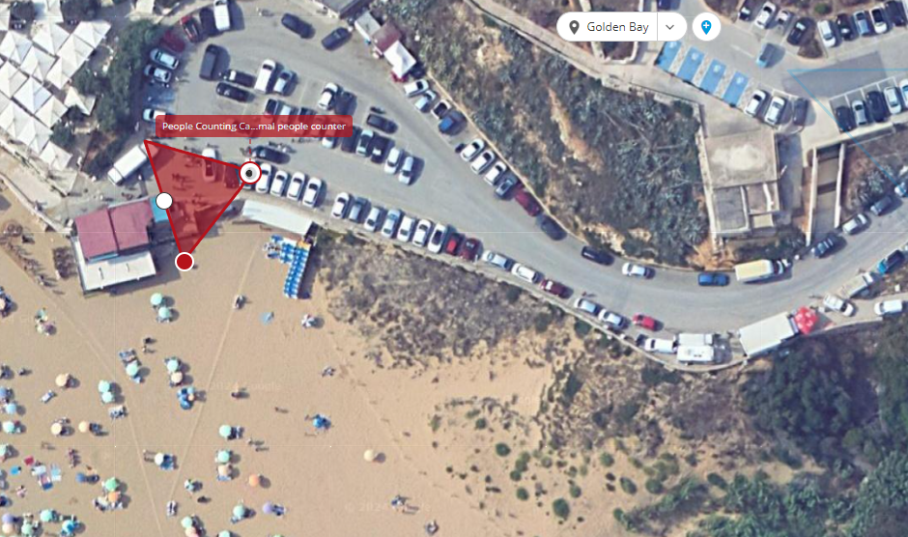

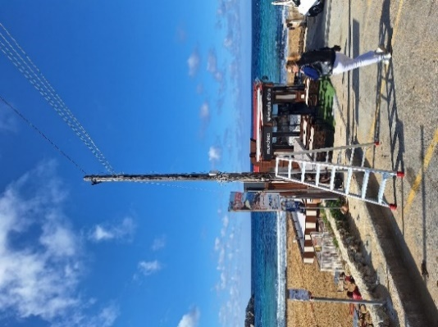

* 1 Fixed Camera on Pole 2, overlooking the hill from beach towards Apple Eye Restaurant for both people and vehicle counting.

*Site Layout #2 – People and car counting camera for Ghajn Tuffieha Bay*

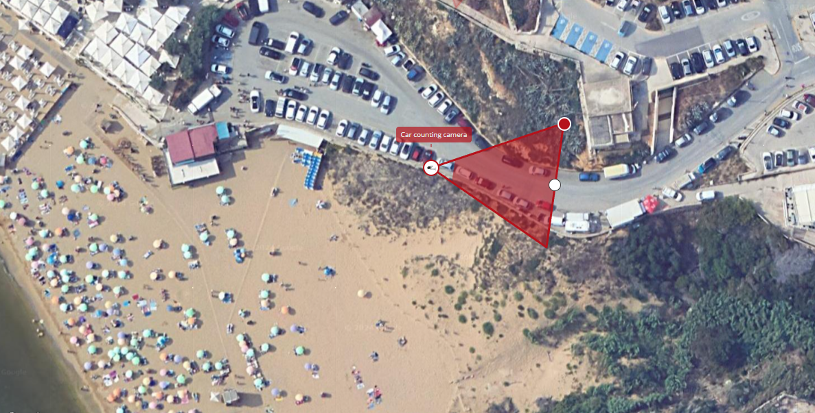   
  
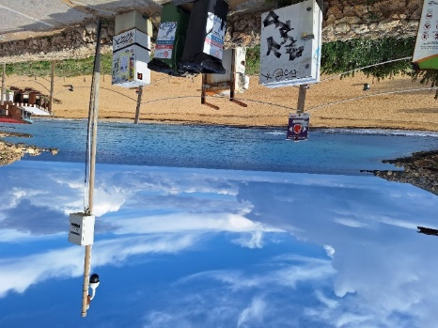

* 1. The People and Traffic counting cameras will be installed at the entrance to Golden Bay.
  2. It is expected that the system will use a Vision Management System or equivalent that will, via the cameras, measure the number of visitors to and from the chosen sites with the following recommended requirements:
* Detection behaviour like Enter, Exit, Appear, Disappear, Stop, Direction, Dwell filter; tailgating; colour Filter; logical rules which extend standard rules to allow various combinations of the inputs, 3D Behaviour Perspective, Corrected Size and Speed Filters.
* Object Classification like Configured Max./Min. object sizes and Max./Min. speeds People Tracking Tracks individuals separately among overlapped multiple people Counting Line High accuracy people and vehicle counting - counting 20 counters in total.
* Near-Live and historical reporting.
* Selectable reports, global views and the ability to drill down to specific groups, selected areas or individual entrances.
* Instant reports.
* Multi layered graphical representation and a simple configurable user interface.
* Automatic PDF or Email reports.
* Automatic data sent to Shared Folders.
* Analysis and sharing of relevant footfall statistics
* Accessible via web page via any device on the network.

## 7.0 Camera Locations for CCTV and live webcam requirements at Golden Bay

* 1 fixed CCTV camera at pole #2 overlooking the beach, long distance for surveillance purposes and a range of 110m. PTZ options also considered.
* 1 Fixed live webcam at Pole 2, overlooking the beach from the road hill for streaming online 24hrs. GDPR compliant.

*Site Layout #3 – CCTV and webcam for Golden Bay*

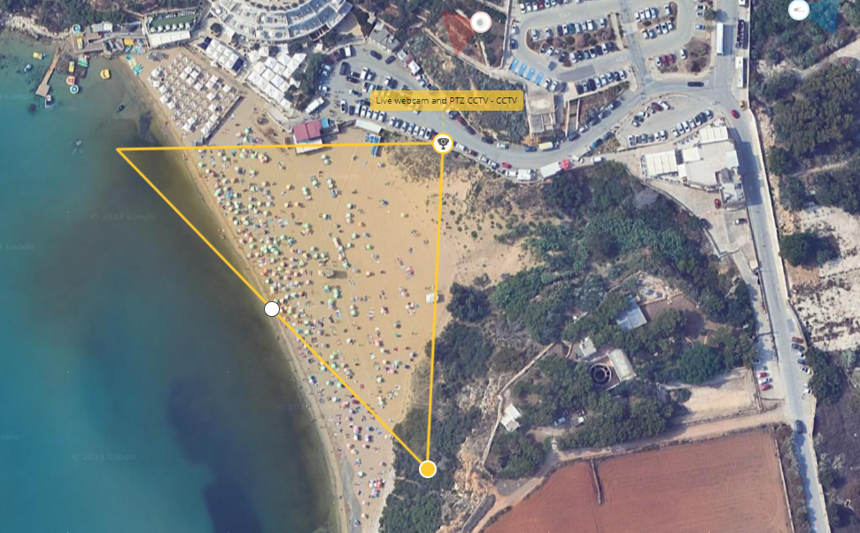

7.1 Four closed-circuit TV cameras will be installed onsite for 24/7 surveillance: One at the beach and three at the Majjistral Park Barracks. The intention is to deter illegal trespassing and assist in environmental monitoring.

7.2 Additionally, the cameras are required to include necessary cloud-based software with remote accessibility and unlimited data connectivity. Cameras will be expected to use the same poles, internet / broadband and power connections as used by the people counting cameras, and already in place. However, data storage and reporting back will be sited on an 8TB server (Dell EMC PowerEdge R440 Server) provided by the client, and hosted at the Visitors Centre at Ghajn Tuffieha barracks**.**

## 8.0 Camera Locations for CCTV at Majjistral Park Visitors Centre

Three fixed CCTV cameras at Majjistral Nature and History Park Visitors’ Centre:

* Camera point #3 at the Barracks, viewing towards the main entrance gate.
* Camera point #4 at the Barracks, point viewing towards the chapel.
* Camera point at Camping area.

*Site Layout #4 – Visitors Centre and Camping Site*

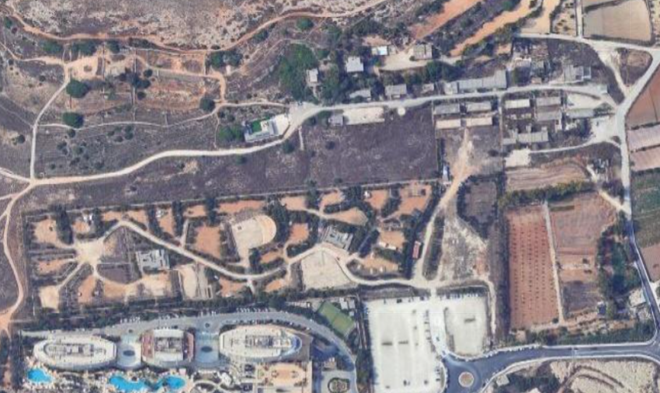

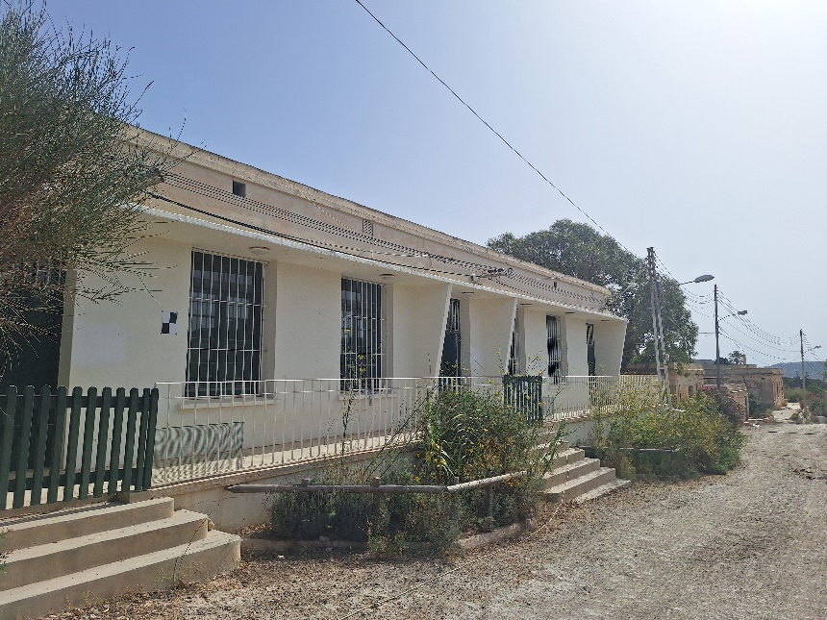

8.1 Cameras will require fixing brackets and will take power from existing supply and utilise the broadband connection network at the barracks. Wi-fi router equipment to cover the Barracks area is to be provided by the contractor.

## 9.0 Training and Maintenance

9.1 Handover and training shall compromise a basic breakdown of system operation, system access and footage retrieval.

9.2 The maintenance price period is for 5 years from installation date – circa August 2024 to August 2029.

9.3 Maintenance and Support Services shall commence on the Go-live date.

9.4 Expected maintenance and support services levels and requirements are indicated in Table 1 below.

*Maintenance and Support Services Levels and Requirements.*

|  |  |  |  |
| --- | --- | --- | --- |
| **Impact Code** | **Problem Description** | **Maximum**  **response time** | **Resolution**  **Time** |
| High Priority (when  dealt locally or  remotely) | A High Priority fault is one where the whole System is out of order. | 4 hours | 1 working  day |
| Low Priority  Maintenance | A Low Priority fault occurs when a malfunction causes a  reduced level of service, but most of the system remains  functional. Moreover, a low priority fault should not seriously affect the  Customer’s operations and where most of the System functions remain operational. | 1 working day | 5 workings  Days |
| * Faults reported after Normal Business Hours shall be considered as reported at 08:00hrs of the following day. * The fault has to be rectified within the timeframes set forth in Table 1. * The Contractor must keep the Customer regularly informed of the responses and actions being taken by any third parties. * The Customer reserves the right to re-prioritise a priority level. * In case of incident resolution that requires configuration of the System, the Contractor is still bound by the above Service Levels. | | | |

## 10.0 Warranty - Material and software

10.1 This Request for Quotations requires that warranty and maintenance be included in the supply and installation price; the run for the life of the contract following acceptance and successful implementation of the system by the supplier.

10.2 The bidder is to submit a declaration that the system is warranted for a minimum period of at least two (2) years. The declaration should include a list of inclusions and exclusions of warranty.

10.3 Before the issue of the Provisional Acceptance Certificate, Structure and System shall be certified by a warranted Installer, cost of certification is to be borne by the bidder.

# Section 2: To be filled in by interested bidders

Quotation date: _____________________

Suppliers/Contractor’s details

|  |  |
| --- | --- |
| Company’s Name: |  |
| Contact Person’s Name and Surname: |  |
| VAT Registration number |  |
| Company’s Address: |  |
| Telephone Number: |  |
| Mobile Number: |  |
| E-mail address: |  |

Price of bid (in Euro) as per stated requirements and specifications in the bill of quantities below:

|  |  |
| --- | --- |
| **Net:** | **€** |
| **Vat (specify rate): %** | **€** |
| **Total:** | **€** |

Company Rubber Stamp:

Signature:

Name and Surname: ___________________________________

|  |  |  |  |  |  |  |
| --- | --- | --- | --- | --- | --- | --- |
| **Bill of Quantities: RfQ for the supply, installation and maintenance of a people / vehicle counting system and CCTV at Golden Bay.** | | | | | |  |
| **#** | **Description** | **Qty** | **Unit** | **Rate EUR (excl. VAT)** | **VAT** | **Total EUR (including. VAT)** |
| 1 | People-Counting network camera for beach entrances; 8MP fixed-focal with AI software. | 1 |  | € |  | € |
| 2. | Thermal People Counting network camera for beach entrances; 8MP fixed-focal with AI software. | 1 |  | € |  | € |
| 3. | People and Vehicle Traffic Counting Camera for beach road; 8MP fixed-focal with AI software. | 1 |  | € |  | € |
| 4. | CCTV PTZ infra-red for beach surveillance. |  |  | € |  | € |
| 5. | Camera to serve as a live webcam. | 1 |  | € |  | € |
| 6. | 3 CCTV Cameras for Visitors Centre – 4MP Bullet cameras. | 3 |  | € |  | € |
| 7. | 5.8G 5km Wireless Bridge with 802.11ac for beach and Visitors centre. | 2 |  | € |  | € |
| 8. | VMS Software license for 16 video channels, and capable of later channel expansion. | 1 |  | € |  | € |
| 9. | Service Level Agreement for the Maintenance and Support Services for a five (5) year period. | 1 |  | € |  | € |
| 10. | Installation, configuration and connection to existing data server at Visitors Centre. | 1 |  | € |  | € |
| 11. | Installation, testing and commissioning. | 1 | Lump Sum | € - | € |  |
| **Total of product and services less VAT** | | | | | **€** |  |
| **Total of product and services inclusive of VAT** | | | | | **€** |  |

**Maintenance of all counters and software support**

|  |  |  |
| --- | --- | --- |
|  | **Year** | **Price per annum price £ (inclusive of VAT)** |
| Maintenance of all cameras on a repair or replace basis to ensure full operation of the system inclusive of bi-annual service visit. | 1st year |  |
|  | Year 2, 3, 4 and 5. |  |
|  | **Maintenance Total for 5 yrs** |  |
| **Grand Total for products, services and maintenance.** | |  |

Company Rubber Stamp:

Signature:

Name and Surname: ___________________________________